DIGITAL ACADEMIC REPOSITORY
AND ARCHIVE (DARA)
A Research Proposal and Study
Presented to the Faculty of Computer Studies Department
ACLC College of Mandaue
Mandaue City, Philippines
In Partial Fulfillment
of the Requirement for the course
Information Assurance 2
By:
Alferez, Neil
Amistoso, Jun-rey
Bautista, Trixie
Faller, Gayle David

August 2024
DEDICATION
This research proposal and study is dedicated to our families, whose unwavering support and encouragement have been our guiding light throughout this journey. To our friends and classmates, whose insights and assistance have been invaluable, we extend our deepest gratitude.

ACKNOWLEDGEMENT
We would like to express our sincere gratitude to ACLC College of Mandaue for providing us with the resources and environment conducive to our academic and professional growth.
A special thank you to our instructor, Sir Noel Lehitimas, for his guidance, expertise, and encouragement throughout the development of this proposal/study. Your mentorship has been instrumental in shaping our understanding and approach.

CHAPTER 1
INTRODUCTION
The "Digital Academic Repository Archive" (DARA) project is an innovative initiative designed to transform how academic records are managed, stored, and accessed within educational institutions. In an era where digital transformation is reshaping the academic landscape, the need for a centralized platform to preserve and disseminate student-generated scholarly work has become increasingly critical.
This project focuses on creating a digital repository for a diverse range of academic documents, including theses, proposals, capstones, case studies, and system studies. By incorporating advanced features such as a custom PDF reader, citation management, tagging, and document categorization, DARA aims to ensure that these academic contributions are not only preserved but also easily accessible and usable for future research and collaboration.
IMPORTANCE OF THE STUDY
The "Digital Academic Repository Archive" (DARA) project is a pivotal initiative aimed at addressing the growing need for a systematic and efficient means of managing academic records within an educational institution. As the academic landscape increasingly embraces digital transformation, the absence of a centralized digital repository for storing and accessing scholarly work can significantly hinder the preservation, dissemination, and utilization of academic output. This study is therefore focused on creating a structured, user-friendly platform that not only archives but also enhances the accessibility of student-generated academic materials.
The importance of this project lies in its potential to revolutionize how academic work is managed. By integrating a range of advanced features such as a custom PDF reader, citation management, tagging, categorization, and tracking of publication and revision dates. DARA will ensure that academic documents are not only preserved but are also readily accessible to students, faculty, and researchers. This will foster a more collaborative academic environment where research can be easily shared, referenced, and built upon, contributing to the overall academic excellence of the institution.

Furthermore, the implementation of DARA will align the institution with contemporary educational standards, where digital repositories are increasingly viewed as essential components of academic infrastructure. DARA enhance the institution's ability to manage its academic records effectively, positioning it as a forward-thinking educational establishment that values the long-term preservation and accessibility of knowledge.

PURPOSE OF THE PROJECT
The purpose of the DARA project is to create a centralized digital platform for the effective management, storage, and dissemination of academic records. This includes student-generated works such as theses, proposals, capstones, case studies, and system studies.
DARA aims to preserve these academic contributions, enhance their accessibility, and support academic research by providing tools for citation management, document categorization, and more. The project is designed to streamline the archival process, promote knowledge sharing, and ensure the long-term preservation of scholarly work.
Additionally, DARA seeks to make these academic records readily available as local studies, enabling other researchers to utilize them as references for their Review of Related Literature (RRL) and Review of Related Studies (RRS).
STATEMENT OF THE PROBLEM
In the current academic environment, student’s studies such as theses, proposals, capstones, thesis, case studies, and other related studies are primarily stored in physical libraries or in disparate digital formats across various platforms. This fragmented approach to storing academic work leads to several issues:
- Limited Accessibility: Many valuable academic studies are not readily accessible to students, researchers, and other institutions, hindering the ability to share knowledge and collaborate effectively.
- Inefficient Search and Retrieval: The absence of a centralized digital repository leads to significant challenges in finding local studies within the Philippines. Due to the fragmented storage of academic documents across various institutions, users face difficulties in locating relevant local research, which impedes the ability to access and utilize these valuable studies effectively.
- Lack of Preservation: Physical storage of academic work poses risks related to deterioration, loss, or damage over time, compromising the long-term preservation of valuable scholarly contributions.
The establishment of a centralized digital repository is crucial to address these problems by providing a comprehensive, accessible, and well-organized system for managing academic documents.
GENERAL PROBLEM
The general problem is that student studies, including theses, proposals, capstones, case studies, and other related studies, are currently stored in physical libraries or disparate digital locations. This approach limits their visibility and accessibility to other institutions and researchers. As a result, local studies and literature are often not available for reference or citation in research conducted at other schools, impeding the sharing of knowledge and collaboration across educational institutions.
SPECIFIC PROBLEMS
- Inadequate Accessibility: Academic studies are confined to physical storage in libraries, making it challenging for students and researchers to access these documents remotely or from different locations. This limitation affects the ability to conduct thorough literature reviews or build on existing research.
- Limited Visibility of Local Research: Studies conducted at a particular institution may not be visible or accessible to other schools or researchers. This lack of visibility prevents the wider dissemination and utilization of local academic contributions.
- Risk of Document Loss or Damage: Physical documents are susceptible to loss, damage, or deterioration over time. The absence of a digital backup exacerbates the risk of losing valuable academic work.
OBJECTIVE OF THE STUDY
- Develop a Centralized Digital Repository:
- Develop a dedicated digital platform for Anonymous School to centralize the storage of academic documents, including theses, proposals, capstones, case studies, and system studies.
- Ensure that this repository is accessible to students, faculty, and researchers who are external users.
- Facilitate Citation Management and Documentation:
- Integrate tools for managing citations and authorship to assist users in generating accurate references and acknowledging contributions within their academic work.
- Ensure that citation management is streamlined and accessible to both students and faculty.
- Ensure Preservation and Security of Academic Work:
- Create a secure system to store and preserve academic documents, protecting them from loss or damage.
- Apply access controls and encryption to safeguard sensitive academic information.
- Streamline Document Submission and Review Processes:
- Create an intuitive interface for students and faculty to submit documents, simplifying the process and ensuring ease of use.
- Implement workflows for document review and feedback to facilitate timely evaluation and processing of academic work.
- Support System Administration and Maintenance:
- Develop administrative tools for managing user accounts, system settings, and permissions specific to Anonymous School.
- Provide features for tracking system performance, usage, and logs to support ongoing maintenance and effective management of the repository.

SOPE
- Document Management:
- Submission: Students can submit academic documents in PDF format and provide metadata, including titles, authors, and other relevant information.
- Metadata Entry: Students enter metadata during the submission process, which is stored alongside the PDF documents.
- Approval and Review: Teachers review submitted documents, provide feedback, and approve, reject, or request revisions.
- Administrative Control: Administrators manage system settings, user roles, and perform maintenance tasks.
- Search Functionality:
- Search Queries: Users can perform searches using text-based queries to find documents. This includes searching within document titles, metadata, and optionally, full-text content.
- User Roles and Privileges:
- Students: Submit documents and metadata, view submission status, and receive feedback.
- Teachers: Review and provide feedback on documents, and manage document status.
- Administrators: Oversee system settings, manage user accounts, and handle system maintenance and performance.
- External Users: Search for documents and metadata.

LIMITATIONS
- Proposal Stage:
- Since the current system is a proposal and not yet implemented. Users and scenarios described are hypothetical and used for planning purposes only.
- User Database:
- The system does not integrate with the school's existing user database or information systems. Users are managed within the DARA system independently.
- Document Format:
- Only PDF documents are accepted. The system does not support other file formats or document types.
- Feedback Mechanism:
- Internal comments or annotations on PDFs are not supported. Feedback is provided through separate communication channels and recorded in the system's feedback logs.
- Search Capabilities:
- The search functionality is limited to queries based on metadata and optionally full-text content. Advanced search features, like contextual understanding and semantic search, are not included in the current scope.

- DOI (Digital Object Identifier)
- The system does not assign or integrate Digital Object Identifiers (DOIs) for the archived documents due to the unavailability of the necessary infrastructure and agreements with DOI-issuing authorities.

SIGNIFICANCE OF THE STUDY
The significance of this study lies in its potential to revolutionize the way academic research and outputs are managed, preserved, and accessed within Anonymous School. By developing the Digital Academic Repository Archive (DARA), this study addresses the critical need for a centralized digital platform where student-generated works such as theses, capstones, proposals, case studies, and system studies can be securely stored and efficiently retrieved.
- Enhancing Accessibility and Visibility
DARA provides an accessible and user-friendly platform where academic materials are easily searchable and retrievable. This increased accessibility ensures that valuable student research is not lost in physical archives but is instead available to current and future students, faculty, and external researchers as local studies and literature. The repository also supports the academic community by providing relevant materials for literature reviews and related research studies (RRLs/RRSs).
- Preserving Academic Contributions
The system ensures the long-term preservation of scholarly work. By converting physical documents into digital formats, DARA safeguards these academic contributions from physical deterioration and loss, ensuring that they remain a valuable resource for generations to come.
- Streamlining the Review and Approval Process
The digital platform facilitates a more efficient review and approval process by enabling teachers to review submissions online, provide feedback, and manage document statuses (e.g., pending, approved, needs revision, rejected). This streamlined process reduces delays and administrative burdens, allowing for quicker dissemination of research findings.
- Supporting Academic Research and Collaboration
By providing tools for citation management, document categorization, and advanced search functionalities, DARA enhances research capabilities. It promotes academic collaboration by allowing multiple users to access, reference, and build upon the work of others, thus fostering a more interconnected and collaborative academic environment.

- Aligning with Modern Educational Practices
The implementation of DARA aligns with the growing trend toward digitalization in education. By embracing digital repositories, Anonymous School positions itself at the forefront of modern academic practices, supporting its mission to provide quality education and foster academic excellence.
In summary, this study is significant not only in its contribution to the technological advancement of Anonymous School but also in its broader impact on the academic community, both within and beyond the institution.

CHAPTER 2
REVIEW OF RELATED STUDIES
RELATED LITERATURE
Digital preservation in institutional repositories: a systematic literature review
Barrueco, José Manuel, and Miquel Termens (2022). "Purpose This paper aims to carry out a literature review on the implementation of digital preservation policies, strategies and actions by institutional repositories. The objective is to identify, out of the published experiences, at which level they are fulfilling the function of ensuring the long-term availability of the deposited materials. Design/methodology/approach Using a systematic literature review methodology, a total of 21 articles from international refereed journals published between 2009 and 2020 are reviewed. Findings The research production on this subject is very limited. The scarce number of published articles proves that the interest of repository managers has been focused on issues other than to assure the long-term availability of the assets they store. The literature review has not found clear evidence about how institutional repositories are implementing digital preservation. It is particularly striking the lack of works focused on the situation in European countries. More field studies are needed. They would allow to extract conclusions and produce best practices to help managers to improve preservation strategies. Originality/value This study has shown that one of the main functions of repositories is not being dealt with as promised by repository managers. More work in this area is needed. In particular, it is necessary for a study at the European level to gather detailed data that will allow to draw a portrait of the current situation, extract conclusions and produce best practices to help managers to improve or develop preservation strategies."
The role of digital scholarship in academic libraries, the case of university of cape coast: opportunities and challenges
Accourding to Ocran, Theophilus Kwamena, and Paulina Afful-Arthur (2022). "Purpose The purpose of the study is to assess the role of academic libraries in digital scholarship at the University of Cape Coast. The study adopted the descriptive survey design and used teaching staff (lecturers) as the population of the study. Design/methodology/approach A sample size of 278 was used for the study. The study used questionnaires to obtain data from participants. The study revealed that faculty members appreciate digital scholarship through the services offered by Sam Jonah Library are relevant to the current higher education context, reliable information, preservation of information resources and facilitating the integration of library services into the learning process are closely integrated into the library service, transform scholarly communication, teaching and learning style and research paradigm. Findings The study revealed that digital scholarship contributes to faculty members' delivery at the University of Cape Coast through the provision of information literacy training for new students, provision of reference lists of materials available in the library and provision of lists of new materials. The study revealed that faculty members face inadequate facilities to enhance digital scholarship, inadequate open access to reading materials (articles, books, etc.), inadequate platforms or suite of tools for librarians to take faculty. Practical implications The application of digital scholarship provides an expansion to the core competitiveness of librarians new services which enables innovativeness and transformation of libraries. Students will be equipped with digital literacy skills; it affords instructors to approach teaching with innovation and scholars are also engaged to perform novel practices in scholarship acquisition. Digital scholarship is the umbrella under which all academic technologies comes under to foster collaboration and better learning experience. Originality/value This paper offers an insight of the role digital scholarship in promoting and advancing scholarship in the academic environment. It highlights a number of digital scholarship platform available in the library. It is observed that digital scholarship practices must be encouraged in the library because it facilitates the role of academic library which is to support teaching, learning and research."
The Library as a Digital Scholarship Hub
According to Christine Abrigo and Donna Lyn Labangon (2021) “With libraries now expected to be online and clients assuming that academic information resources are available and accessible publicly on the Internet anytime, the digital environment provided opportunities for the libraries to mature in their learning support for their school communities. This had been made even more pronounced when the COVID-19 pandemic affected the world over, moving all services and programs to shift heavily to the digital environment. While advanced libraries have been prominently embedding Library 4.0 in their learning support systems, the pandemic pushed many, if not all, libraries to consider developmental directions involving the heavy use of digital technologies in scholarship. This study aimed at exploring the digital scholarship (DS) service opportunities in libraries by means of benchmarking on the DS services and practices of the top higher education institution libraries in Asia in 2020, which endeavors to serve as baseline in coming up with a proposed DS hub development plan for Philippine academic libraries. The descriptive survey design using website investigation to screen data was employed, drawing up an instrument to contextualize the DS services mined from these websites, then categorized based on the determined and desired DS services environment. A DS services scan of the libraries of top-ranking Asian universities with that of the Philippines' best were mapped to get a perspective of the status of the latter's DS services, providing insights in coming up with a DS program plan. Data revealed that while leading Asian university libraries have moved away from the traditional types of services, content and framework, its Philippine counterparts' services were deemed emerging. Subject expertise upskilling among librarians in the fields of data research management, data services and digital technologies, as well as an intensified librarian engagement in DS partnerships and projects in the academic community were seen as opportunities for a responsive DS service. The output of this study has potential use in guiding Philippine academic libraries in coming up with their own framework and roadmap towards instituting their own DS services hub, to leverage learning support in their respective communities.”
R2S: A REPOSITORY PLATFORM FOR RESEARCH OFFICES IN THE HIGHER EDUCATION INSTITUTION (HEI's) IN THE PHILIPPINES
We chose Chester Cofino, Debbie B. Enquilino, and Mark John Salao’s (2022) study, "R2S: A Repository Platform for Research Offices in Higher Education Institutions (HEIs) in the Philippines," as a related study because it addresses key challenges and solutions relevant to our project on the Digital Academic Repository System. The study highlights the importance of a central repository for managing and organizing academic theses and research outputs, a function central to our proposed system. Cofino, Enquilino, and Salao’s research shows that their R2S platform effectively handles issues such as file duplication and retrieval, providing a systematic approach to data management. Their conclusions confirm that a well-designed repository system can greatly benefit research offices by improving data accessibility, security, and efficiency. These insights are directly applicable to our study, as they illustrate the practical advantages and user requirements for effective digital repository systems in academic settings.

RELATED STUDIES
Digital Transformation and Access to Scholarly Research: ETD Management and Digital Repository of Indian Agricultural System
Neena Singh’s (2023) study is related to our study because it highlights the critical need for timely access to scholarly information in today’s knowledge-driven society. Singh's work underscores the importance of digital repositories in addressing the challenges of underutilized physical research assets, such as theses and dissertations, and in promoting open access to scholarly work. This aligns with our study's focus on implementing a digital academic repository system and archive, which seeks to facilitate quicker access to research outputs, prevent duplication, and uphold academic integrity.
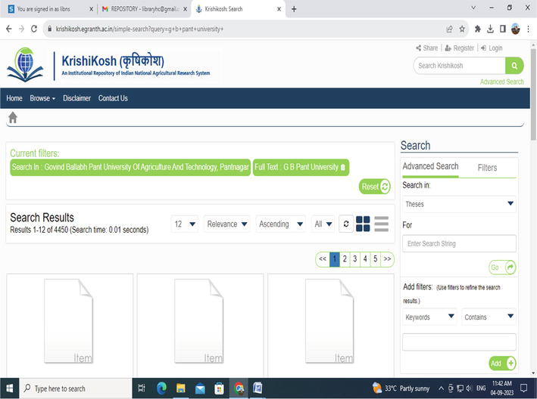
FIGURE 1: FOREIGN RELATED STUDY 1
Importance of Digital Library in Academic Institutions
We chose Anupam Chanda's (2021) study as a related study because it highlights the crucial role that digital libraries play in modern academic institutions and provides insights directly applicable to our project. Chanda's findings indicate that a significant majority of academic users are not only aware of digital library systems but also actively use them for their studies, with 82.36% acknowledging their importance. Chanda concludes that digital libraries are essential for providing easy and widespread access to resources, saving both time and space for users, and reducing the need for physical visits to libraries. These findings underscore the importance of our study on the proposal, highlighting the ongoing need for digital solutions in academic settings and the potential impact of our project in overcoming some of the barriers identified by Chanda.
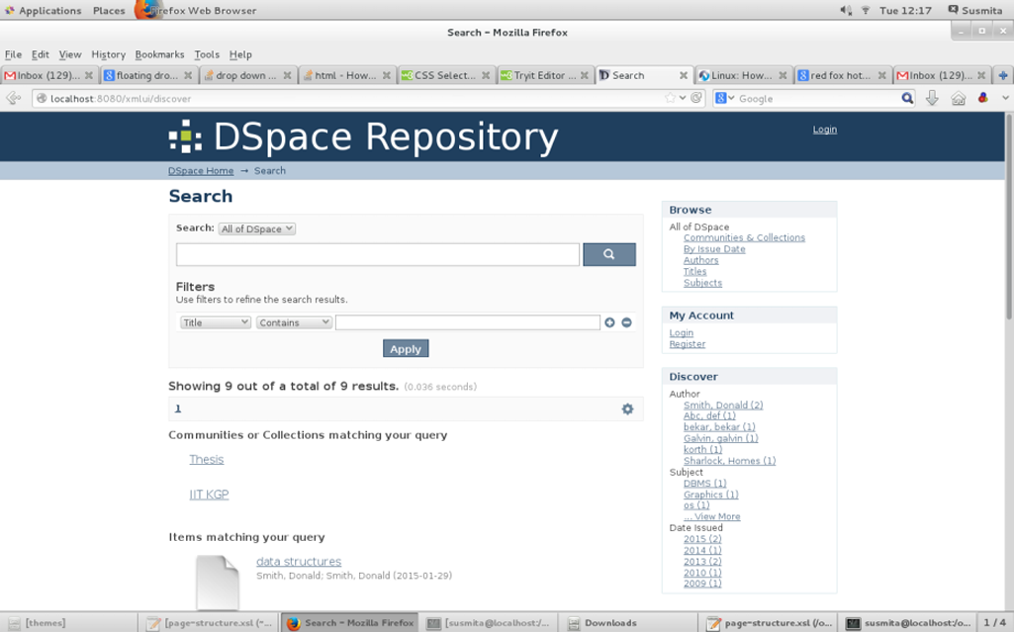
FIGURE 2: FOREIGN RELATED STUDY 2
DEVELOPING A RECORD ARCHIVING SYSTEM IN EASTERN VISAYAS STATE UNIVERSITY – BURAUEN CAMPUS
We chose Elpidio Cabitlada Villarosa's (2021) study because it addresses key issues related to transitioning from paper-based to digital records management. Villarosa's focus on creating a paperless system, improving data retrieval, and ensuring reliable backups aligns with our DARA project’s goal of enhancing the management, storage, and accessibility of academic records. His findings provide valuable insights for developing our centralized digital repository and addressing similar challenges in academic settings.
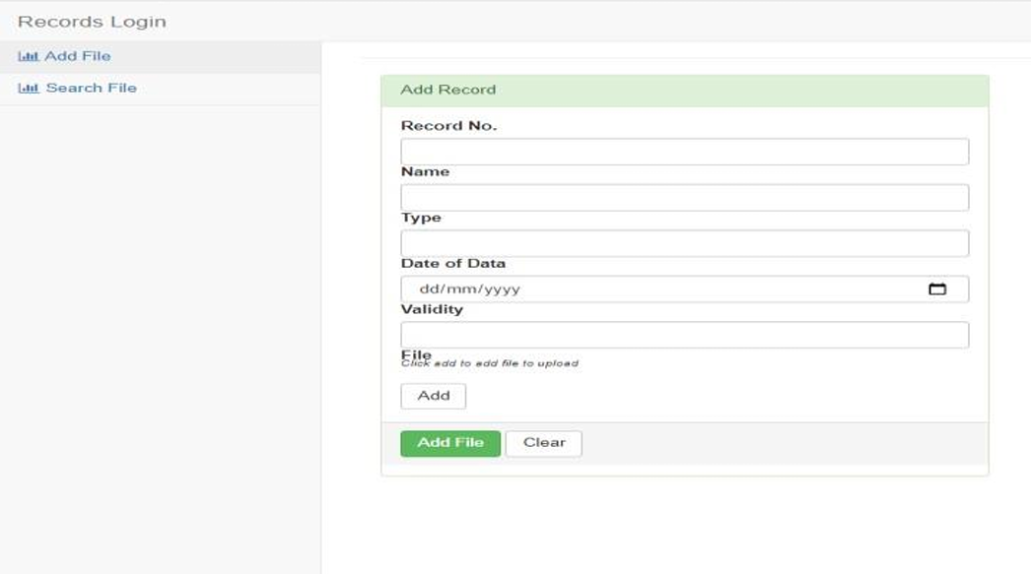
FIGURE 3: LOCAL RELATED STUDY 1
Case Study of the Deployment of Mobile Library Resources Application (MoLiRA) in Academic Institution
We selected Jose Naldrix D. Rivera's (2021) study, because it explores how mobile technology can enhance library services. Rivera's research demonstrates the effectiveness of mobile applications in providing access to diverse library resources, which is pertinent to our DARA project. The findings on user satisfaction and mobile accessibility offer useful insights for incorporating advanced features into our digital repository, aiming to improve how academic records are managed and accessed.
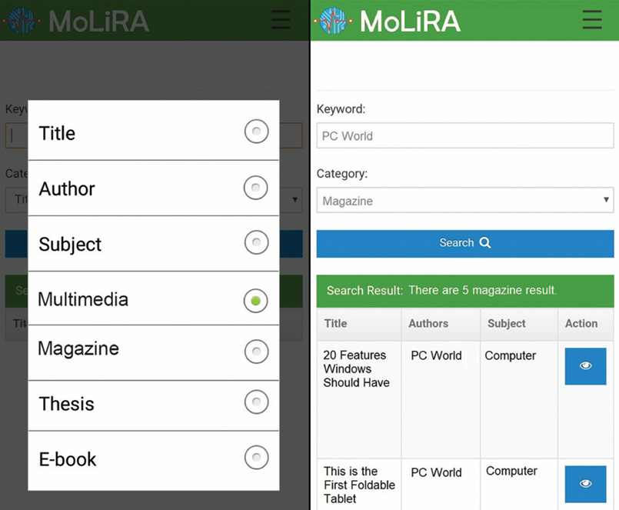
FIGURE 4: LOCAL RELATED STUDY 2
CHAPTER 3
TECHNICALITY OF THE PROJECT
The DARA system is designed to be a robust, scalable digital repository for academic documents. It leverages a combination of PHP, MySQL, and JavaScript to manage the submission, storage, review, and retrieval of student studies, ensuring that these valuable resources are preserved and accessible for future research.
The system’s architecture supports multiple user roles, comprehensive metadata management, and secure handling of PDF files, making it a powerful tool for academic institutions.

DETAILS OF THE TECHNOLOGY
SOFTWARE
Software | Definition
Database | A structured collection of data that is organized and accessible in various ways. It is commonly used to store and manage information efficiently.
Any Free Web  Browser | A software application used to access information on the World Wide Web. Examples include Google Chrome, Mozilla Firefox, and Microsoft Edge, among others.
Operating System | Software that manages computer hardware and provides services for computer programs. Examples include Windows, macOS, Linux, and Android.
PHP | A popular scripting language used for web development to create dynamic and interactive web pages. It is often embedded into HTML and runs on a web server.
Visual Studio Code | A free source-code editor developed by Microsoft for Windows, Linux, and macOS. It supports debugging, syntax highlighting, and intelligent code completion.
XAMPP | A free and open-source cross-platform web server solution stack package developed by Apache Friends. It includes Apache HTTP Server, MySQL database, and interpreters for scripts written in PHP and Perl.
Table 1: Software Development Requirements

HARDWARE
Hardware | Definition
Solid State Drive (SSD) | A storage device that uses integrated circuit assemblies to store data persistently. SSDs typically offer faster data access and retrieval than traditional mechanical hard disk drives (HDDs).
Keyboard | An input device used for typing text and executing commands on a computer. Keyboards usually consist of alphanumeric keys, function keys, and special keys for navigation and control.
Monitor | A display screen for computers and other electronic devices. Monitors provide visual output from the computer, allowing users to view text, graphics, and videos.
Mouse | A pointing device that detects two-dimensional motion relative to a surface. It allows users to interact with graphical user interfaces by moving a cursor and selecting items on the screen.
Power Supply Unit | A hardware component that supplies electrical power to a computer or other electronic devices. PSUs convert mains AC electricity to low-voltage regulated DC power for the internal components of the computer.
Central Processing Unit | The primary component of a computer that performs instructions defined by software. The CPU is often referred to as the brain of the computer and executes arithmetic, logical, control, and input/output operations specified by instructions.
Random Access Memory | A form of computer memory that can be accessed randomly. RAM is used by the operating system and applications to store data temporarily, allowing quick access for processing tasks. It is volatile memory, meaning data is lost when the computer is powered off unless saved elsewhere.
Table 2: Hardware Development Requirements
CONNECTIVITY
Connectivity | Definition
CAT6 Cable | Category 6 cable, commonly abbreviated as CAT6, is a type of Ethernet cable used in wired networking. It supports Gigabit Ethernet speeds up to 1,000 Mbps and frequencies of up to 250 MHz. CAT6 cables are known for their improved performance and reduced crosstalk compared to earlier categories like CAT5e.
Wi-Fi Router | A device that allows multiple devices to connect to a local area network (LAN) wirelessly and access the internet. It typically acts as a central hub for Wi-Fi connectivity in homes, offices, and public spaces, providing wireless access to devices such as smartphones, tablets, laptops, and smart home devices.
Table 3: Connectivity of the Project

LET MSYSQL ACCEPT BIG FILES
- Open XAMPP
- Start Apache and MySQL
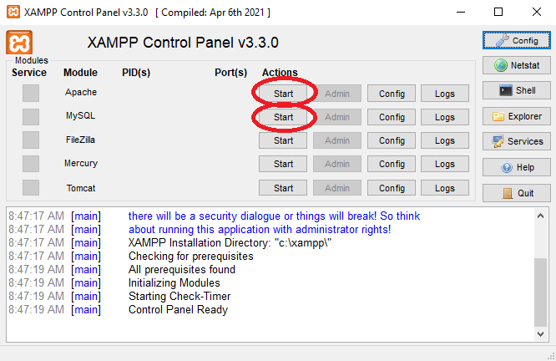
- Click Admin on MySQL
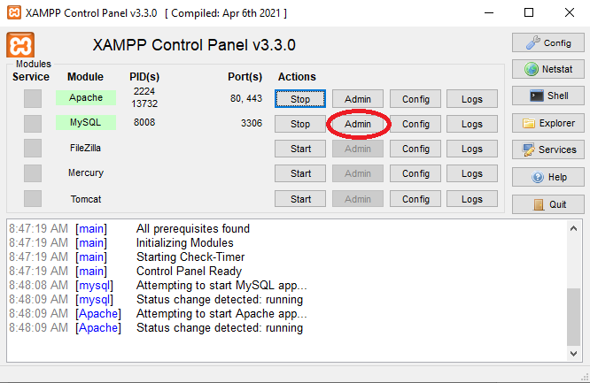
- In the localhost, locate “Variables”
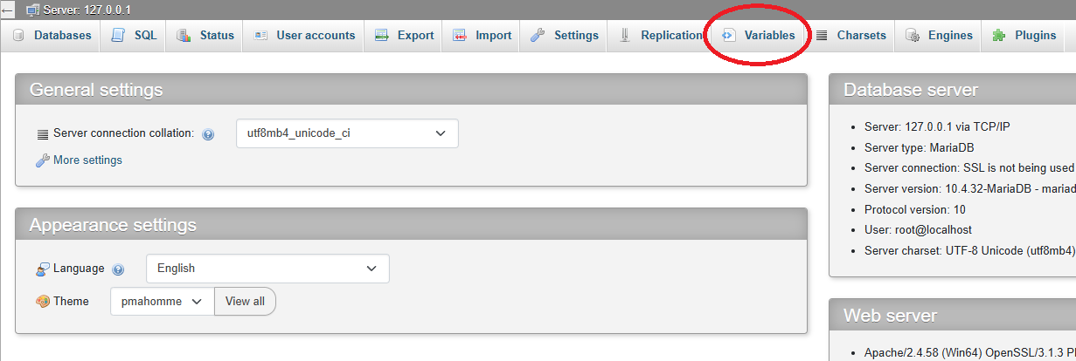
- Type “packet”
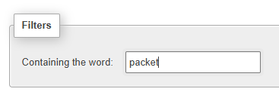
- Edit max allowed packet
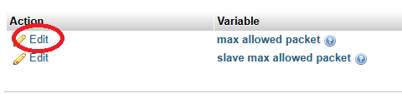
- Max allowed packet should be: 16777216
- Save
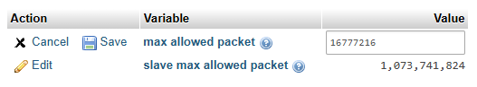

DEVELOPMENT PHASE
HARDWARE
Development Requirements
Installed Memory | 4GB 1600MHz
Processor | Ryzen A10-6700T@2.5GHz
System Type | 64-bit OS, x64-based processor
Table 4: Hardware Development Requirements
SOFTWARE
Development Requirements
Browser | Chrome, Edge, or Firefox
Language | PHP and JS
OS | 64-bit OS, x64-based processor
IDE | Visual Studio Code
XAMPP | Latest Version
Table 5: Software Development Requirements

DEPLOYMENT PHASE
HARDWARE
Development Requirements
CPU | Ryzen 5 3200g
Storage | 256GB 2.5” SSD
Keyboard | Membrane Keyboard
Monitor | AOC
Mouse | A4Tech
RAM | DDR4 8GB 2666MHz
Table 6: Hardware Deployment Requirements
SOFTWARE
Development Requirements
Browser | Chrome, Edge, or Firefox
Language | PHP and JS
IDE | Visual Studio Code
XAMPP | Latest Version
Table 7: Software Deployment Requirements

PROPOSED SYSTEM
The Digital Academic Repository Archive (DARA) is envisioned as a comprehensive digital platform designed to manage and store academic documents such as theses, capstones, and case studies. This system will serve as a centralized repository for students, teachers, and administrators, offering streamlined processes for submitting, reviewing, and managing academic records.
With the implementation of DARA, students will have the ability to submit their academic work in PDF format, accompanied by detailed metadata that enhances the organization and retrieval of documents. Teachers will be empowered to review and approve submissions or request revisions, ensuring that only quality work is archived.
Additionally, administrators will have control over system management, user accounts, and settings, maintaining the integrity and efficiency of the repository. A key feature of DARA is its integrated PDF viewer, which allows users to view documents alongside their metadata, providing a seamless and user-friendly experience.

HOW THE PROJECT WILL WORK
The development and implementation of the DARA system will follow a structured process, starting with the design of the database and user interfaces, and the integration of essential features such as the PDF viewer and metadata management tools. Once the system is operational, the document submission process will be straightforward for students, who will upload their documents along with comprehensive metadata. Upon submission, the documents will enter a pending state, awaiting review by teachers. The review process is critical, as teachers will either approve the documents for inclusion in the repository or request revisions to ensure academic standards are met.
Metadata management will play a crucial role in the system, as it allows for the categorization and tagging of documents, making them easily searchable and retrievable. Users, including students and faculty, will benefit from the ability to search for and view documents within the system, with the PDF viewer providing a detailed display of both the document and its associated metadata. The system's administration will involve regular maintenance and oversight by administrators, who will manage user accounts, perform backups, and ensure the smooth operation of the repository. As the DARA system evolves, there is potential for future enhancements, such as the introduction of advanced search options or integration with other academic systems, further enhancing its utility and effectiveness in managing academic records.
CHAPTER 4
METHODOLOGY
DATAFLOW DIAGRAM
This section outlines the flow of data within the existing system and the proposed system for DARA. The dataflow diagram (DFD) illustrates the processes, data stores, data flow, and other entities involved in the system. It provides a visual representation of how data moves through the system, highlighting the sources, destinations, storage points, and pathways that data follows. This diagram serves as a crucial tool for understanding the current system's operations and identifying potential areas for improvement in the proposed system.
ACTORS/ENTITIES  - Student  - Teacher  - External User  - Administrator | DATA STORES  - Document Repository  - User Database  - Notification Logs
LIST OF EVENTS/PROCESS
- Academic Document Submission and Cataloging
- Review and Approval
- Browsing and Accessing Repository
- System Administration and Maintenance
- Notification and Feedback Management
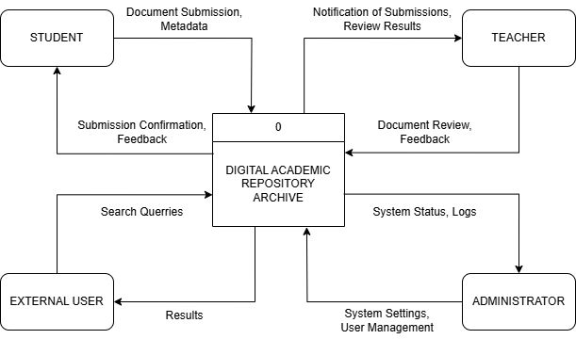
FIGURE 5: CONTEXT DIAGRAM
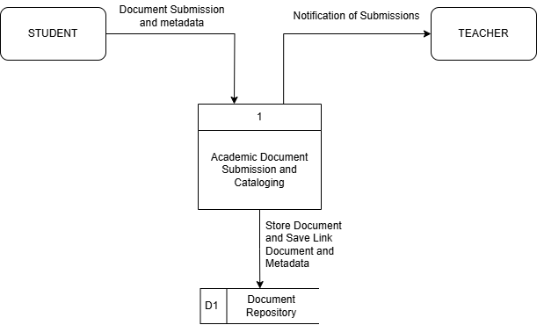
FIGURE 6: DFD PROCESS 1
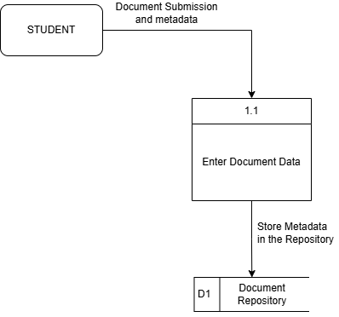 | 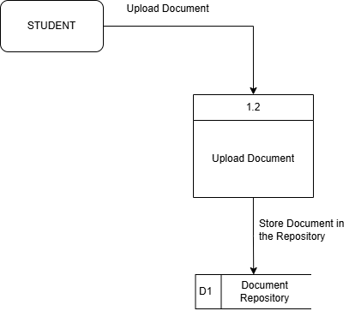
FIGURE 7: DFD PROCESS 1.1 | FIGURE 8: DFD PROCESS 1.2

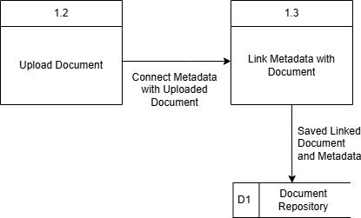 | 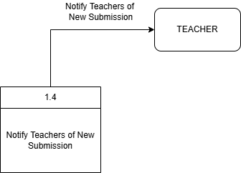
FIGURE 9: DFD PROCESS 1.3 | FIGURE 10: PROCESS DFD 1.4

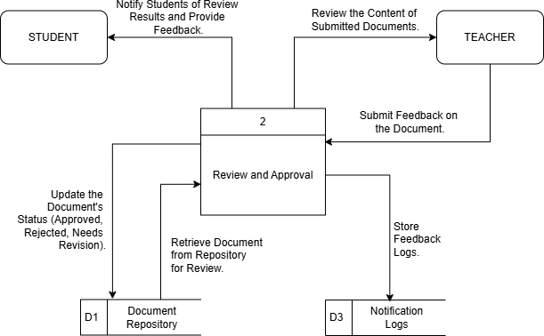
FIGURE 11: DFD PROCESS 2
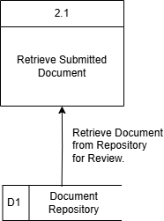 | 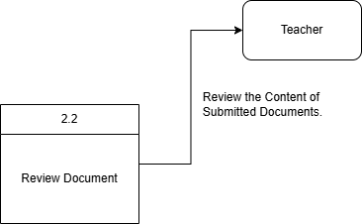
FIGURE 12: PROCESS DFD 2.1 | FIGURE 13: DFD PROCESS 2.2

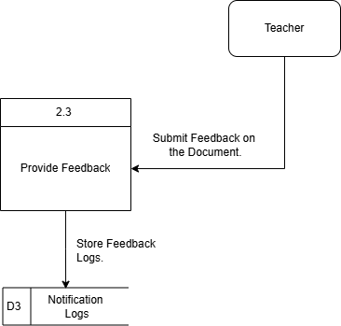 | 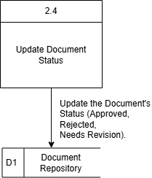
FIGURE 14: PROCESS DFD 2.3 | FIGURE 15: DFD PROCESS 2.4

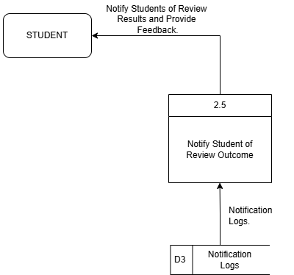
FIGURE 16: DFD PROCESS 2.5
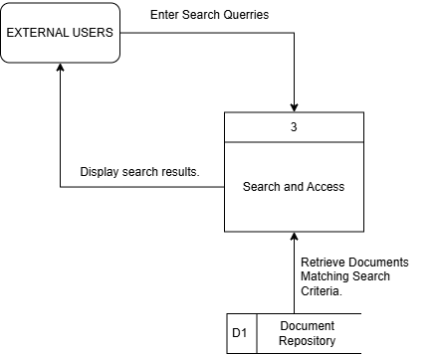
FIGURE 17: DFD PROCESS 3
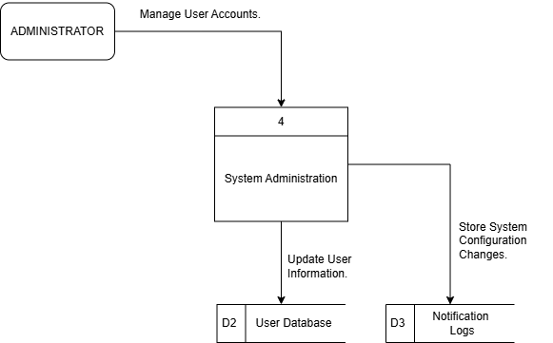
FIGURE 18: DFD PROCESS 4
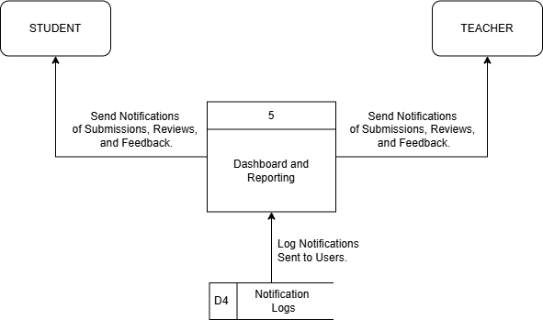
FIGURE 19: DFD PROCESS 5
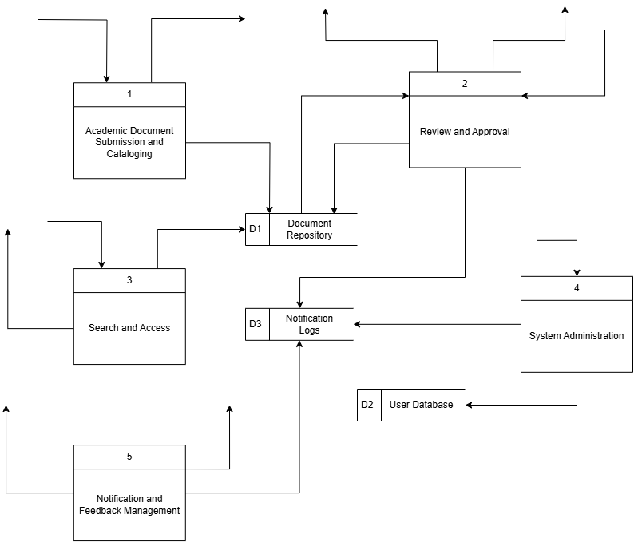
FIGURE 20: TOP LEVEL DFD
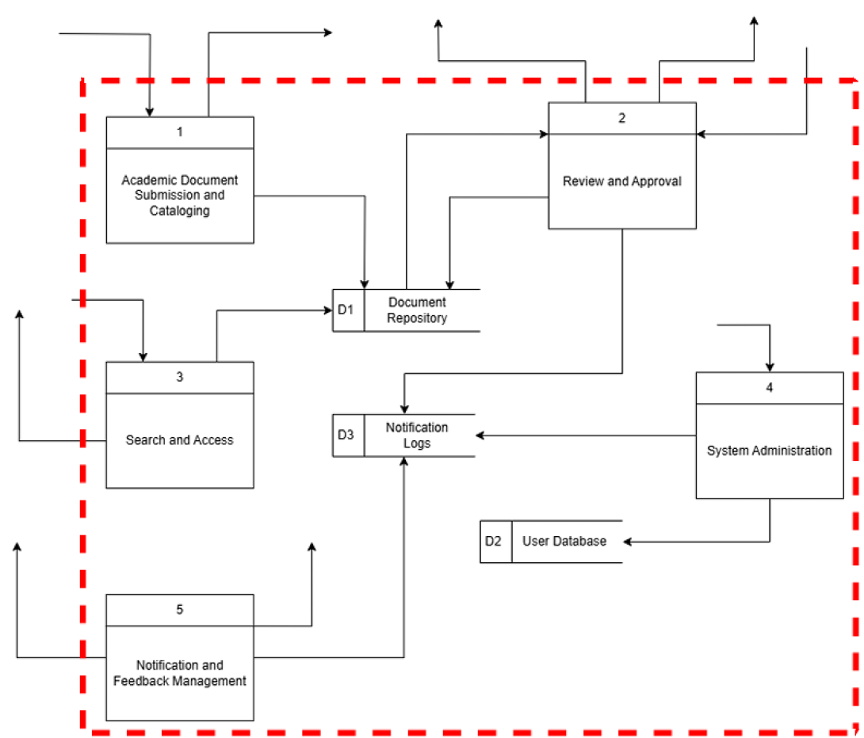
FIGURE 21: AUTOMATION BOUNDARY
WORK BREAKDOWN STRUCTURE
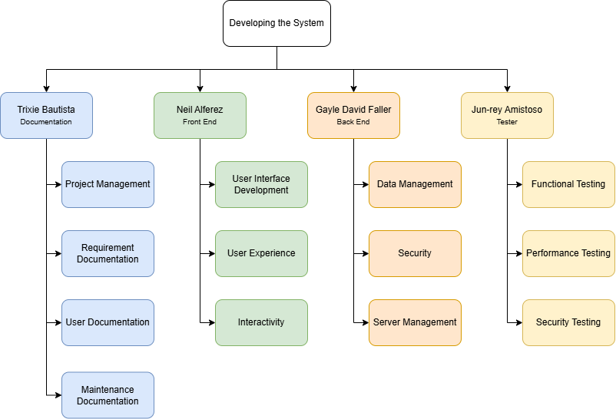
FIGURE 22: WORK BREAKDOWN STRUCTURE
USE CASE DIAGRAM
SYSTEM DIAGRAM
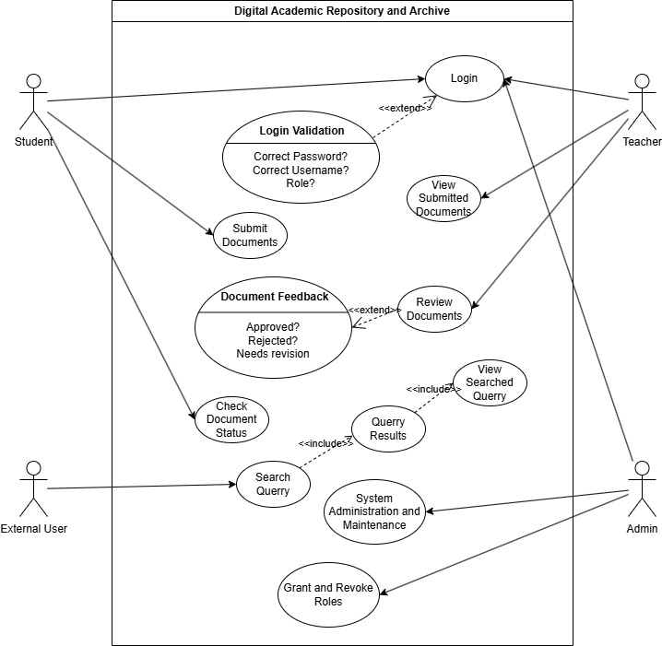
FIGURE 23: SYSTEM USE CASE DIAGRAM

STUDENT
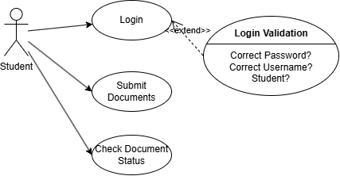
FIGURE 23: STUDENT USE CASE DIAGRAM
TEACHER
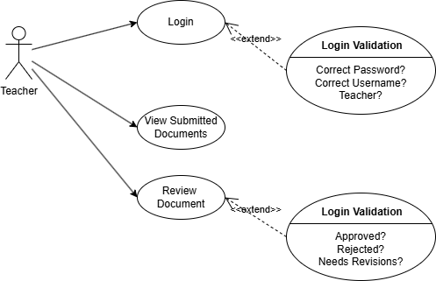
FIGURE 24: TEACHER USE CASE DIAGRAM

EXTERNAL USER
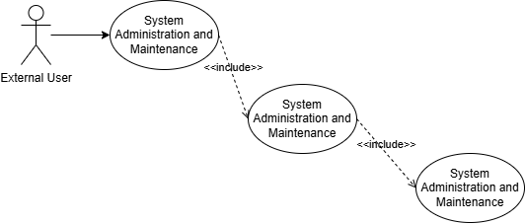
FIGURE 25: EXTERNAL USER USE CASE DIAGRAM
ADMIN
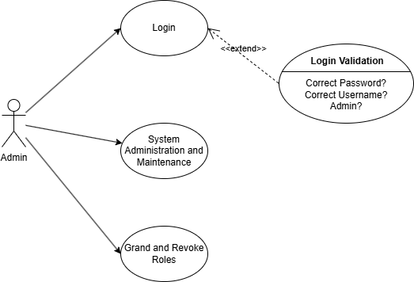
FIGURE 26: ADMINUSE CASE DIAGRAM

